Synchro and RADAR
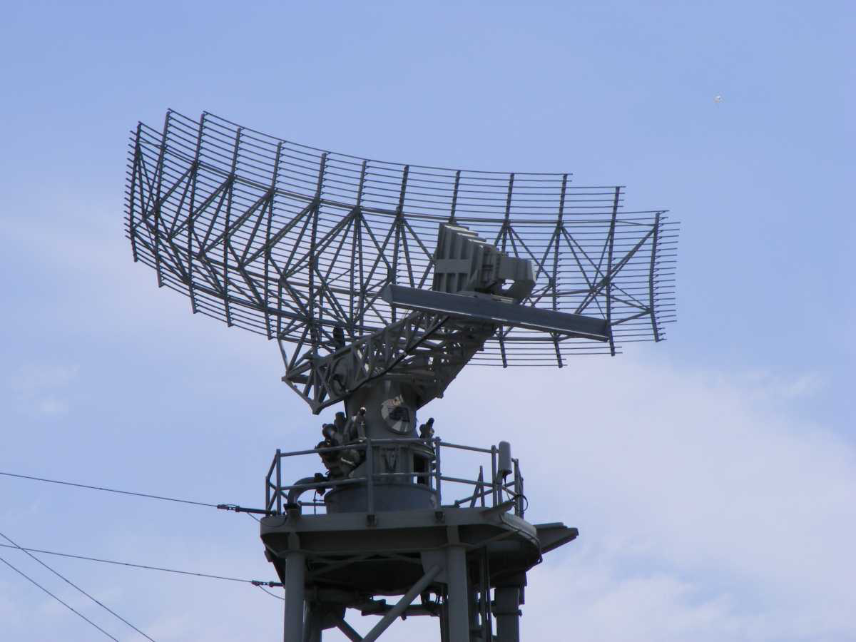
A synchro is a nearly obsolete device that reported the position of a remote shaft. Modern services use digital devices to send the position of a shaft to a computer or other device. A big application was early RADAR system where the position of the RADAR antenna was reported to a device that displayed radar “hits.”

What to Build

To simulate a RADAR system: build a tower with a motor attached to a sweeping antenna. Also build a remote display device using a motor with an arm that indicates the direction and sweep of the antenna. Real life examples are to the right.
RADAR antenna

How to Code
One motor is the remote sending device and another motor is the receiving device. Lego Spike can read the angular position of the sending motor and command the receiving device to turn to the same angle.
RADAR display

Blocks that you need to build the synchro program:

Start block

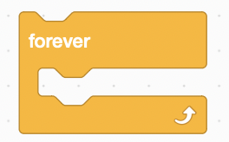
Loop forever


read (sensor) motor angle


turn (receiving) motor to a specific angle

More Fun
The program can also control the position of the sending device to turn around and around or back and forth like a real radar system with any of the blue single motor control blocks. To ease the construction of the code, you can use a second start block for a separate program for these motor controls. The first program will continue sending the position from the sending motor to the receiving motor.

